How to resolve Caused by: java.net.BindException: Address already in use: bind error

This error will occur when you try to install jenkins

Error :

**Comman : C:\Users\Narayana>java -jar E:\Jenkins\jenkins.war**

Running from: E:\Jenkins\jenkins.war

webroot: $user.home/.jenkins

[33mSep 09, 2018 6:31:57 PM Main deleteWinstoneTempContents

WARNING: Failed to delete the temporary Winstone file C:\Users\Narayana\AppData\Local\Temp\winstone\jenkins.war

[0mSep 09, 2018 6:31:57 PM org.eclipse.jetty.util.log.Log initialized

INFO: Logging initialized @1892ms to org.eclipse.jetty.util.log.JavaUtilLog

Sep 09, 2018 6:31:57 PM winstone.Logger logInternal

INFO: Beginning extraction from war file

[33mSep 09, 2018 6:31:58 PM org.eclipse.jetty.server.handler.ContextHandler setContextPath

WARNING: Empty contextPath

[0mSep 09, 2018 6:31:58 PM org.eclipse.jetty.server.Server doStart

INFO: jetty-9.4.z-SNAPSHOT

Sep 09, 2018 6:32:02 PM org.eclipse.jetty.webapp.StandardDescriptorProcessor visitServlet

INFO: NO JSP Support for /, did not find org.eclipse.jetty.jsp.JettyJspServlet

Sep 09, 2018 6:32:02 PM org.eclipse.jetty.server.session.DefaultSessionIdManager doStart

INFO: DefaultSessionIdManager workerName=node0

Sep 09, 2018 6:32:02 PM org.eclipse.jetty.server.session.DefaultSessionIdManager doStart

INFO: No SessionScavenger set, using defaults

Sep 09, 2018 6:32:02 PM org.eclipse.jetty.server.session.HouseKeeper startScavenging

INFO: Scavenging every 660000ms

Jenkins home directory: C:\Users\Narayana\.jenkins found at: $user.home/.jenkins

Sep 09, 2018 6:32:06 PM org.eclipse.jetty.server.handler.ContextHandler doStart

INFO: Started w.@55cb6996{/,file:///C:/Users/Narayana/.jenkins/war/,AVAILABLE}{C:\Users\Narayana\.jenkins\war}

Sep 09, 2018 6:32:06 PM org.eclipse.jetty.server.AbstractConnector doStop

INFO: Stopped ServerConnector@4b8d604b{HTTP/1.1,[http/1.1]}{0.0.0.0:8080}

Sep 09, 2018 6:32:06 PM org.eclipse.jetty.server.session.HouseKeeper stopScavenging

INFO: Stopped scavenging

Sep 09, 2018 6:32:06 PM hudson.WebAppMain contextDestroyed

INFO: Shutting down a Jenkins instance that was still starting up

java.lang.Throwable: reason

at hudson.WebAppMain.contextDestroyed(WebAppMain.java:388)

at org.eclipse.jetty.server.handler.ContextHandler.callContextDestroyed(ContextHandler.java:898)

at org.eclipse.jetty.servlet.ServletContextHandler.callContextDestroyed(ServletContextHandler.java:545)

at org.eclipse.jetty.server.handler.ContextHandler.stopContext(ContextHandler.java:873)

at org.eclipse.jetty.servlet.ServletContextHandler.stopContext(ServletContextHandler.java:355)

at org.eclipse.jetty.webapp.WebAppContext.stopWebapp(WebAppContext.java:1507)

at org.eclipse.jetty.webapp.WebAppContext.stopContext(WebAppContext.java:1471)

at org.eclipse.jetty.server.handler.ContextHandler.doStop(ContextHandler.java:927)

at org.eclipse.jetty.servlet.ServletContextHandler.doStop(ServletContextHandler.java:271)

at org.eclipse.jetty.webapp.WebAppContext.doStop(WebAppContext.java:569)

at org.eclipse.jetty.util.component.AbstractLifeCycle.stop(AbstractLifeCycle.java:89)

at org.eclipse.jetty.util.component.ContainerLifeCycle.stop(ContainerLifeCycle.java:142)

at org.eclipse.jetty.util.component.ContainerLifeCycle.doStop(ContainerLifeCycle.java:160)

at org.eclipse.jetty.server.handler.AbstractHandler.doStop(AbstractHandler.java:124)

at org.eclipse.jetty.server.Server.doStop(Server.java:523)

at org.eclipse.jetty.util.component.AbstractLifeCycle.stop(AbstractLifeCycle.java:89)

at winstone.Launcher.shutdown(Launcher.java:307)

at winstone.Launcher.<init>(Launcher.java:167)

at winstone.Launcher.main(Launcher.java:354)

at sun.reflect.NativeMethodAccessorImpl.invoke0(Native Method)

at sun.reflect.NativeMethodAccessorImpl.invoke(Unknown Source)

at sun.reflect.DelegatingMethodAccessorImpl.invoke(Unknown Source)

at java.lang.reflect.Method.invoke(Unknown Source)

at Main._main(Main.java:312)

at Main.main(Main.java:136)

Sep 09, 2018 6:32:06 PM org.eclipse.jetty.server.handler.ContextHandler doStop

INFO: Stopped w.@55cb6996{/,null,UNAVAILABLE}{C:\Users\Narayana\.jenkins\war}

Sep 09, 2018 6:32:06 PM winstone.Logger logInternal

INFO: Winstone shutdown successfully

java.io.IOException: Failed to start Jetty

at winstone.Launcher.<init>(Launcher.java:156)

at winstone.Launcher.main(Launcher.java:354)

at sun.reflect.NativeMethodAccessorImpl.invoke0(Native Method)

at sun.reflect.NativeMethodAccessorImpl.invoke(Unknown Source)

at sun.reflect.DelegatingMethodAccessorImpl.invoke(Unknown Source)

at java.lang.reflect.Method.invoke(Unknown Source)

at Main._main(Main.java:312)

at Main.main(Main.java:136)

**Caused by: java.net.BindException: Address already in use: bind**

at sun.nio.ch.Net.bind0(Native Method)

at sun.nio.ch.Net.bind(Unknown Source)

at sun.nio.ch.Net.bind(Unknown Source)

at sun.nio.ch.ServerSocketChannelImpl.bind(Unknown Source)

at sun.nio.ch.ServerSocketAdaptor.bind(Unknown Source)

at org.eclipse.jetty.server.ServerConnector.open(ServerConnector.java:298)

at org.eclipse.jetty.server.AbstractNetworkConnector.doStart(AbstractNetworkConnector.java:80)

at org.eclipse.jetty.server.ServerConnector.doStart(ServerConnector.java:236)

at org.eclipse.jetty.util.component.AbstractLifeCycle.start(AbstractLifeCycle.java:68)

at org.eclipse.jetty.server.Server.doStart(Server.java:431)

at org.eclipse.jetty.util.component.AbstractLifeCycle.start(AbstractLifeCycle.java:68)

at winstone.Launcher.<init>(Launcher.java:154)

... 7 more

Exception in thread "Jenkins initialization thread" [31mSep 09, 2018 6:32:06 PM winstone.Logger logInternal

SEVERE: Container startup failed

java.io.IOException: Failed to start Jetty

at winstone.Launcher.<init>(Launcher.java:156)

at winstone.Launcher.main(Launcher.java:354)

at sun.reflect.NativeMethodAccessorImpl.invoke0(Native Method)

at sun.reflect.NativeMethodAccessorImpl.invoke(Unknown Source)

at sun.reflect.DelegatingMethodAccessorImpl.invoke(Unknown Source)

at java.lang.reflect.Method.invoke(Unknown Source)

at Main._main(Main.java:312)

at Main.main(Main.java:136)

**Caused by: java.net.BindException: Address already in use: bind**

at sun.nio.ch.Net.bind0(Native Method)

at sun.nio.ch.Net.bind(Unknown Source)

at sun.nio.ch.Net.bind(Unknown Source)

at sun.nio.ch.ServerSocketChannelImpl.bind(Unknown Source)

at sun.nio.ch.ServerSocketAdaptor.bind(Unknown Source)

at org.eclipse.jetty.server.ServerConnector.open(ServerConnector.java:298)

at org.eclipse.jetty.server.AbstractNetworkConnector.doStart(AbstractNetworkConnector.java:80)

at org.eclipse.jetty.server.ServerConnector.doStart(ServerConnector.java:236)

at org.eclipse.jetty.util.component.AbstractLifeCycle.start(AbstractLifeCycle.java:68)

at org.eclipse.jetty.server.Server.doStart(Server.java:431)

at org.eclipse.jetty.util.component.AbstractLifeCycle.start(AbstractLifeCycle.java:68)

at winstone.Launcher.<init>(Launcher.java:154)

... 7 more

[0mjava.lang.NoClassDefFoundError: hudson/util/HudsonFailedToLoad

at hudson.WebAppMain$3.run(WebAppMain.java:247)

Caused by: java.lang.ClassNotFoundException: hudson.util.HudsonFailedToLoad

at java.net.URLClassLoader.findClass(Unknown Source)

at java.lang.ClassLoader.loadClass(Unknown Source)

at java.lang.ClassLoader.loadClass(Unknown Source)

at org.eclipse.jetty.webapp.WebAppClassLoader.loadClass(WebAppClassLoader.java:560)

at java.lang.ClassLoader.loadClass(Unknown Source)

... 1 more

**1)Open the CMD prompt and run the comand**

Command : Netstat -a -o -n

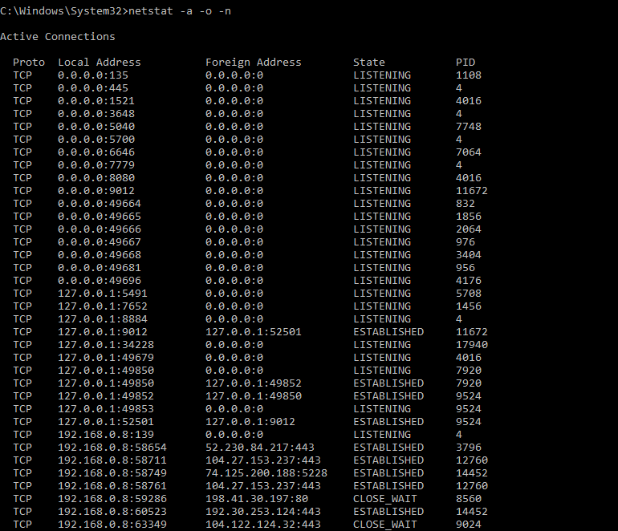

Kill the port 8080

Command : taskill /F /PID 4016 [4016-8080 port PID]